January 10th, 2023

Dear Deltona High School Parent or Guardian,

On five (5) dates identified on the back of this letter, we at DELTONA HIGH SCHOOL will begin to show videos addressing Safety, Decision Making, Substance Abuse Prevention and Mental Health to meet the state mandate for required instruction in these areas. Our scheduled lessons will talk about mental and emotional health and wellness.

The program used for this lesson is the MBF Teen Safety Matters, which teaches teens about emotional, physical, and digital safety. It is based on the latest research and has been reviewed and endorsed by national experts. Within the lesson, they will learn about the MBF Teen Safety Matters Safety Rules:
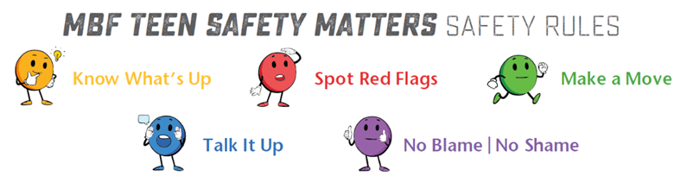
Objectives for this lesson include the following:
- Define Mental Health and Mental Illness
- Identify Common Mental Health Issues (Specifically Anxiety & Depression)
- Impact of Social Media on Anxiety
- Signs of Mental Illness
- Reducing the Stigma of Mental Illness
- Mental Health and Wellness/Well-Being
- Coping Skills & Resilience

If you DO NOT want your child to participate in the program lessons, please complete the following digital form to submit your request to the school. Please do not hesitate to contact the school with any concerns before opting your child out of the program. Scan the QR code below for quick access to the digital form or click on the link to access the digital opt-out form is: https://forms.office.com/r/53FzArJpw1

RESOURCES TO LEARN MORE:
- www.pacer.org/bullying/resources/parents/
- www.kidshealth.org/en/parents/child-abuse.html
- www.polarisproject.org/human-trafficking
- www.loveisrespect.org
- www.mbfpreventioneducation.org

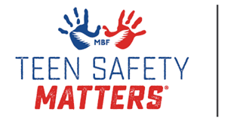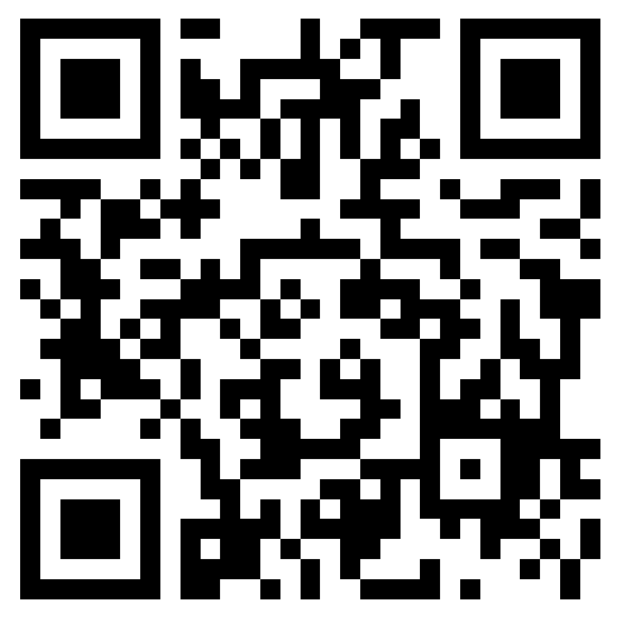
MENTAL HEALTH & SAFETY CURRICULUM
2022-2023

Dear Deltona High School Parent of Guardian:
Florida legislation (6A-1.094124) requires all students, grades 6th -12th, to receive instruction in mental health, child trafficking prevention, and substance abuse. In Volusia County schools, students will plan to receive this instruction through a developmentally appropriate lesson within their class day. Parent Information Sheets will follow the videos providing additional follow up that you may want to discuss or review with your students at home in the form of a Connect Ed message. Lesson topics will include the following:

Introduction to Mental Health, Physical Health & Wellbeing | General understanding to help reduce stigma
Coping Skills | Ways to manage and reduce stress and challenges
Signs of Mental Illness | Understand how to recognize the signs and how to seek help for themselves and their friends, if needed
Seeking Help | Who to reach out to for help, in terms of a trusted adult or helping professional, and about local and national resources that can be accessed when help is needed
Safety & Substance Abuse | How to recognize and respond to bullying/cyberbullying, abuse, digital dangers, and substance abuse. It teaches that adults are responsible for their safety but there are things they can do to help adults keep them safe

Programs used for this year are a combination of the Monique Burr Foundation’s Teen Safety Matters® Program and Lauren’s Kids Safer, Smarter Teens curriculum, both have which been reviewed and endorsed by national experts and implemented in districts throughout the State of Florida.
You can learn more about these programs at www.mbfpreventioneducation.org and www.LaurensKids.org and www.SaferSmarterSchools.org .

When teens are taught safety information, rules to keep them safe, and better understand their own wellness, they perform better in school and enjoy healthier, happier, and safer lives.

IF YOU “DO NOT” WANT YOUR TEEN TO PARTICIPATE IN THE PROGRAM LESSONS, COMPLETE THE FOLLOWING DIGITAL FORM TO SUBMIT YOUR REQUEST TO THE SCHOOL. SCAN THE QR CODE ON THE FRONT PAGE FOR QUICK ACCESS OR CLICK ON THE LINK TO THE DIGITAL OPT-OUT FORM IS: https://forms.office.com/r/53FzArJpw1

The lessons provide students with important information about mental wellness, communicating concerns, and potential dangers they may face. If you do not want your teen to participate, please have these discussions with them or use another program. Please contact the school with any concerns before opting your teen out of the program.

At DELTONA HIGH SCHOOL lessons will be delivered in the classroom by your child’s current “elective/non-core” teachers on a rotation. Mental Health Counselors and School Counselors will be made available for any students who may be triggered or need to debrief about any of the material. Lessons will rotate classes so as not to impede on the instructional time of one particular subject. Dates and class period include the following:

Friday January 27th, 2023 (2nd Period)
Friday February 10th, 2023 (3rd Period)
Friday February 24th, 2023 (4th Period)
Friday March 31st, 2023 (5th Period)
Friday April 14th, 2023 (6th Period)

